**A Major Project Report**

**On**

**PREDICTING LIFE EXPECTANCY USING ML**

**Submitted in partial fulfillment of the**

**Requirements for the award of**

**INTERNSHIP CERTIFICATE**

**IN**

**MACHINE LEARNING**

**Submitted By**

**syamala devi**

**Under the guidance of**

**Mr.CHARAN**

**ACKNOWLEDGEMENT**

I would like to express our sincere thanks to Mr.charan for his motivation and co-

operation for the successful completion of the project.

I would like to Express our sincere thanks to my ML-6 batch friends for their encouragement to achieve the goals of the project

syamala devi

**DECLARATION**

This is to Certify that the project work entitles “Predicting life Expectancy” submitted to smartinternz in partial fulfillment of the requirement for the award of Internship certificate is an original work carried out by R.Praneeth under the guidance of Mr.Charan. This matter embodied in this project is a genuine work, done by me.

**syamala devi**

**Abstract:** The scope of our project is to examine the mortality of patients by using machine learning .Our project tries to create a model based on data provided by the wrold health organisation to evaluate the life expectancy of different countries in years.The main objective of our project is to predict the average life of people in more accurate way than the previous methods.

**Introdution:**

 Life expectancy plays an important role when decisions about the final phase of life need to be made.Good prognostication for example helps to determine the course of treatment and helps to anticipate the procurement of health care services and facilities or more broadly; facilitates advance care planning.Adavance care planning is the process during which patients make decisions about the health care they wish to receive in the future, in case the patients loses the capacity of making decisions or communicating about them.Successful ACP enchances the quality of life and death for palliative patients,by providing timey palliative care and documenting preferences regarding resuscitation and enthanasia among other things.Accurate prognosis of life expectancy is essential for general practitioners to decide when to introduce the topics of ACP to the patients and it is a key determinant in end-of-life decisions.Increasingly the accuracy of prognoses has the potential to benifit patients in various ways by enabling more consistent ACP's earlier and better anticipation on palliative needs and preventing excessive treatment .This study focuses on automatic life expectancy prediction based on medical records .Although medical records ,they remain underutilized for developing clinical decision support systems and improving health care in general.EMR's are characterized by irregularly sampled time series data, missing values,long-term dependencies involving symptoms,diagnosis and interventions,and are prone to documentation errors.Moreover they contain important information in the form of unstructured ,textual data from which information cannot be extracted straight forwadly .These challenges lead to sub optimal use and even waste of large portions of data ,especially when the data is unstructured and noisy .Free texts makeup a significant and important part EMR data, but their ambiguous and noisy character and the lack of canonical forms of medical concepts and the relations between them make it difficult to mine these texts effectively.

**REQUIREMENTS:**

**Functional Requirements:**

* Data set
* Electronic design automation(EDA) etc..

**Non-Functional Requirements:**

* IBM watson
* Node-red
* Processor etc..

**CONCLUSION:**

Our research shows that machine learning and natural processing techniques offers a feasible and promising approach to predicting life expectancy.The research has potential for real life applications such as supporting timely recognition of the right moment to start Adavance care planning.

**Overall Description:**

The main aim of project is to create a user interface which can be helpful for predicting life expectancy of particular country.Inorder to achieve that one we use IBM cloud platform services. IBM clouds platform services provides us to implement machine learning services in associate with Watson studios by using those services we create project in Watson studios where we can import our dataset as asset and add Auto AI services to project then we select the predicting column after that we can deploy our model. But our project is not yet ready.

Another main step in our project is to create user interface in associate with deployed ML project which we create in Watson studios. To achieve that one, we use node-red service in IBM platform. In node-red we use form node to create UI,function node for input,wbm node to integrate ml service to UI,guard node for displaying predicted value.

**Data Flow DIAGRAM:**

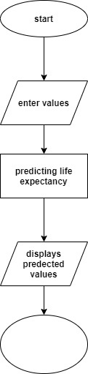

**Sample code :**

|  |
| --- |
| {"id":"265dd308.76498c","type":"tab","label":"Flow 3","disabled":false,"info":""},{"id":"116f2abe.69fe75","type":"wml","z":"265dd308.76498c","name":"rp","connection":"a215b92d.e98fb8","wml-mode":"runPrediction","model":"ea44e0db-09fa-4894-98ee-d6be1a6c4ef0","deployment":"e0de2dc2-523f-4938-ac9e-a8b15bfa9ea3","modelhidden":"ea44e0db-09fa-4894-98ee-d6be1a6c4ef0","deploymenthidden":"","x":430,"y":260,"wires":[["909a4939.ea7dd8","2305e492.8a128c","aab9adc5.f5087","4e78cfa1.87e6b"]]},{"id":"d90bd0d9.0093a","type":"ui_form","z":"265dd308.76498c","name":"","label":"","group":"7cb91b07.f8af64","order":1,"width":0,"height":0,"options":[{"label":"country","value":"co","type":"text","required":true,"rows":null},{"label":"year","value":"ye","type":"number","required":true,"rows":null},{"label":"status","value":"st","type":"text","required":true,"rows":null},{"label":"adult mortality","value":"am","type":"number","required":true,"rows":null},{"label":"infant deaths","value":"ind","type":"number","required":true,"rows":null},{"label":"Alcohol","value":"al","type":"number","required":true,"rows":null},{"label":"percentage expenditure","value":"pe","type":"number","required":true,"rows":null},{"label":"Hepatitis B","value":"he","type":"number","required":true,"rows":null},{"label":"Measles","value":"me","type":"number","required":true,"rows":null},{"label":"BMI","value":"bm","type":"number","required":true,"rows":null},{"label":"under five deaths","value":"un","type":"number","required":true,"rows":null},{"label":"Polio","value":"pol","type":"number","required":true,"rows":null},{"label":"Total expenditure","value":"te","type":"number","required":true,"rows":null},{"label":"Diphtheria","value":"di","type":"number","required":true,"rows":null},{"label":"HIV/AIDS","value":"ha","type":"number","required":true,"rows":null},{"label":"GDP","value":"gd","type":"number","required":true,"rows":null},{"label":"Population","value":"po","type":"number","required":true,"rows":null},{"label":"thinness 1-19 years","value":"th","type":"number","required":true,"rows":null},{"label":"thinness 5-9 years","value":"thi","type":"number","required":true,"rows":null},{"label":"Income composition of resources","value":"inc","type":"number","required":true,"rows":null},{"label":"Schooling","value":"sc","type":"number","required":true,"rows":null}],"formValue":{"co":"","ye":"","st":"","am":"","ind":"","al":"","pe":"","he":"","me":"","bm":"","un":"","pol":"","te":"","di":"","ha":"","gd":"","po":"","th":"","thi":"","inc":"","sc":""},"payload":"","submit":"submit","cancel":"cancel","topic":"","x":150,"y":160,"wires":[["54ab4da7.c60d54"]]},{"id":"909a4939.ea7dd8","type":"debug","z":"265dd308.76498c","name":"","active":true,"tosidebar":true,"console":false,"tostatus":false,"complete":"payload","targetType":"msg","x":690,"y":180,"wires":[]},{"id":"54ab4da7.c60d54","type":"function","z":"265dd308.76498c","name":"","func":"msg.payload = {values:[[\nmsg.payload.co,msg.payload.ye,msg.payload.st,msg.payload.am,msg.payload.ind,msg.payload.al,msg.payload.pe,msg.payload.he,msg.payload.me,msg.payload.bm,msg.payload.un,msg.payload.pol,msg.payload.te,msg.payload.di,msg.payload.ha,msg.payload.gd,msg.payload.po,msg.payload.th,msg.payload.thi,msg.payload.inc,msg.payload.sc],[\nmsg.payload.co,msg.payload.ye,msg.payload.st,msg.payload.am,msg.payload.ind,msg.payload.al,msg.payload.pe,msg.payload.he,msg.payload.me,msg.payload.bm,msg.payload.un,msg.payload.pol,msg.payload.te,msg.payload.di,msg.payload.ha,msg.payload.gd,msg.payload.po,msg.payload.th,msg.payload.thi,msg.payload.inc,msg.payload.sc]]}\nreturn msg;","outputs":1,"noerr":0,"x":290,"y":260,"wires":[["116f2abe.69fe75"]]},{"id":"5c1fc0e7.b4be8","type":"ui_text","z":"265dd308.76498c","group":"7cb91b07.f8af64","order":2,"width":0,"height":0,"name":"","label":"life expectancy","format":"{{msg.payload}}","layout":"row-spread","x":720,"y":100,"wires":[]},{"id":"2305e492.8a128c","type":"function","z":"265dd308.76498c","name":"global","func":"global.set(\"pred\",msg.payload.predictions[0].values[1])\nreturn msg;","outputs":1,"noerr":0,"x":490,"y":360,"wires":[[]]},{"id":"aab9adc5.f5087","type":"function","z":"265dd308.76498c","name":"pred","func":"var pred=global.get(\"pred\")\nreturn {payload:msg.payload.predictions[0].values[1]}","outputs":1,"noerr":0,"x":632,"y":385,"wires":[["924507da.a55588"]]},{"id":"924507da.a55588","type":"ui_gauge","z":"265dd308.76498c","name":"","group":"7cb91b07.f8af64","order":2,"width":0,"height":0,"gtype":"gage","title":"life prediction","label":"percentage","format":"{{value}}","min":0,"max":"100","colors":["#00b500","#e6e600","#ca3838"],"seg1":"","seg2":"","x":810,"y":340,"wires":[]},{"id":"4e78cfa1.87e6b","type":"function","z":"265dd308.76498c","name":"pred","func":"var pred=global.get(\"pred\")\nreturn {payload:msg.payload.predictions[0].values[1]}","outputs":1,"noerr":0,"x":530,"y":120,"wires":[["5c1fc0e7.b4be8"]]},{"id":"a215b92d.e98fb8","type":"wml-config","z":"","host":"https://eu-gb.ml.cloud.ibm.com","instanceid":"75f8411c-ec24-4915-8a1d-6f2559e48f12","name":"wdp-writer"},{"id":"7cb91b07.f8af64","type":"ui_group","z":"","name":"rp","tab":"62a9f009.03709","order":3,"disp":true,"width":"6","collapse":false},{"id":"62a9f009.03709","type":"ui_tab","z":"","name":"chef","icon":"dashboard","disabled":false,"hidden":false}] |

**Screenshots:**

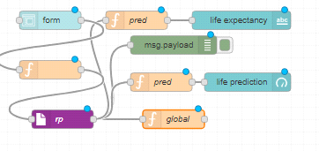

**Fig:1 node-red flow**

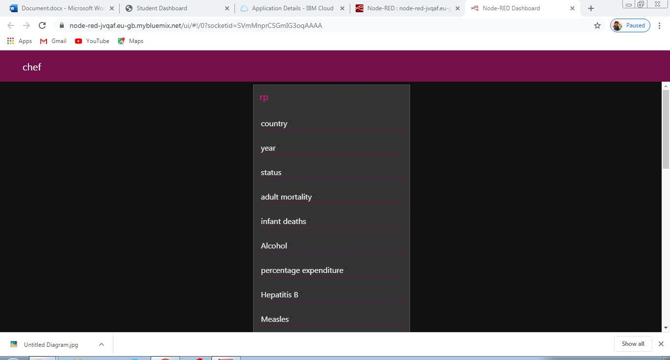 Fig2:user interface

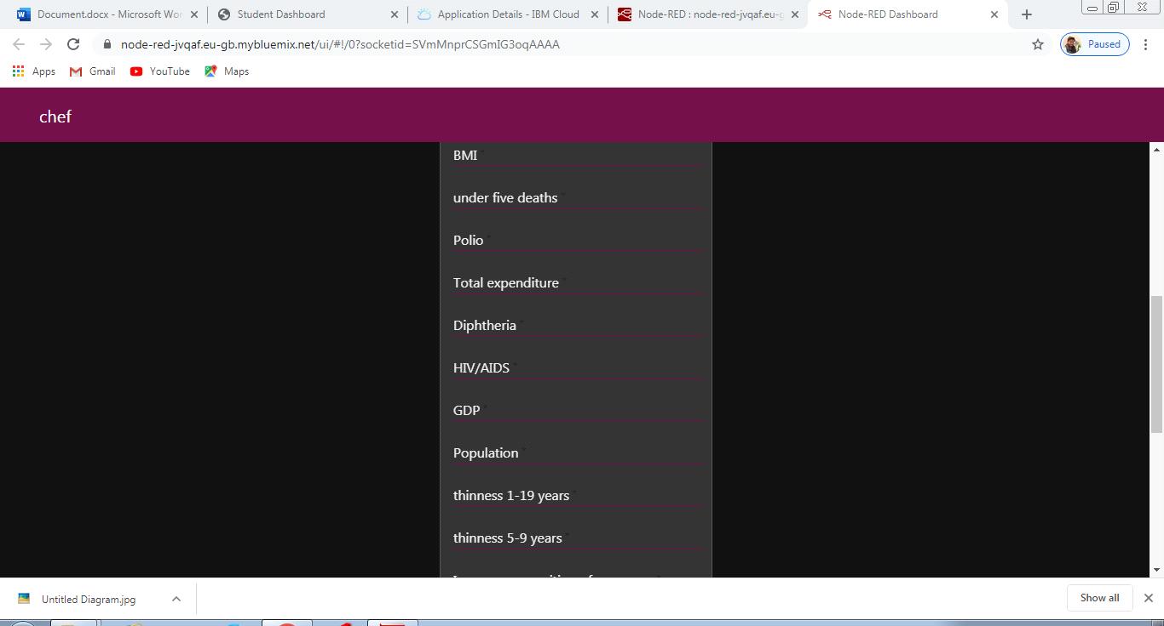

**Fig 3: user interface**

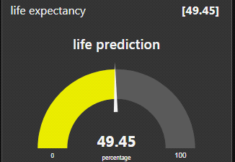

Fig 4: output

**Conclusion:**

Finally, we conclude that this user interface is very useful in predicting life expectancy with more accurate than other old methods used in the past.

THANK YOU